Experiment3
MeasurementofECGsignals

We had to design a twin-T notch filter and a band pass filter optimised to measure ECG signals. This had to be followed by routing the circuit on a PCB. After the fabrication of the PCB, we implemented the circuit on the PCB using an instrumentation amplifier and the components available in the lab.

CircuitDesignandSimulation

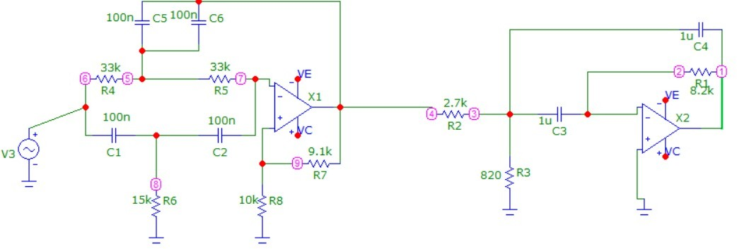

CIRCUITDESIGNED

Note: The notch-filter used in the circuit was highly sensitive to precise values of resistors. Due to the availability of components in the lab, the circuit notch appears at 77 Hz instead of theintended 50 Hz.

Notch FilterDesign

Toachieveanotchat50Hz,weusethefundamentalfrequencyformula: fc = 1/2πRC
Let'ssaywechoseC=100nF. Calculate R:
R=1/(2π⋅50Hz⋅100nF)≈31.8kΩ

Forthenotchtobeefficient,theT-branchesmustbesymmetrical:
- R4=R5=R
- R6=R/2≈15kΩ
- C1= C2 = C
- C5+C6 =2C= 200nF
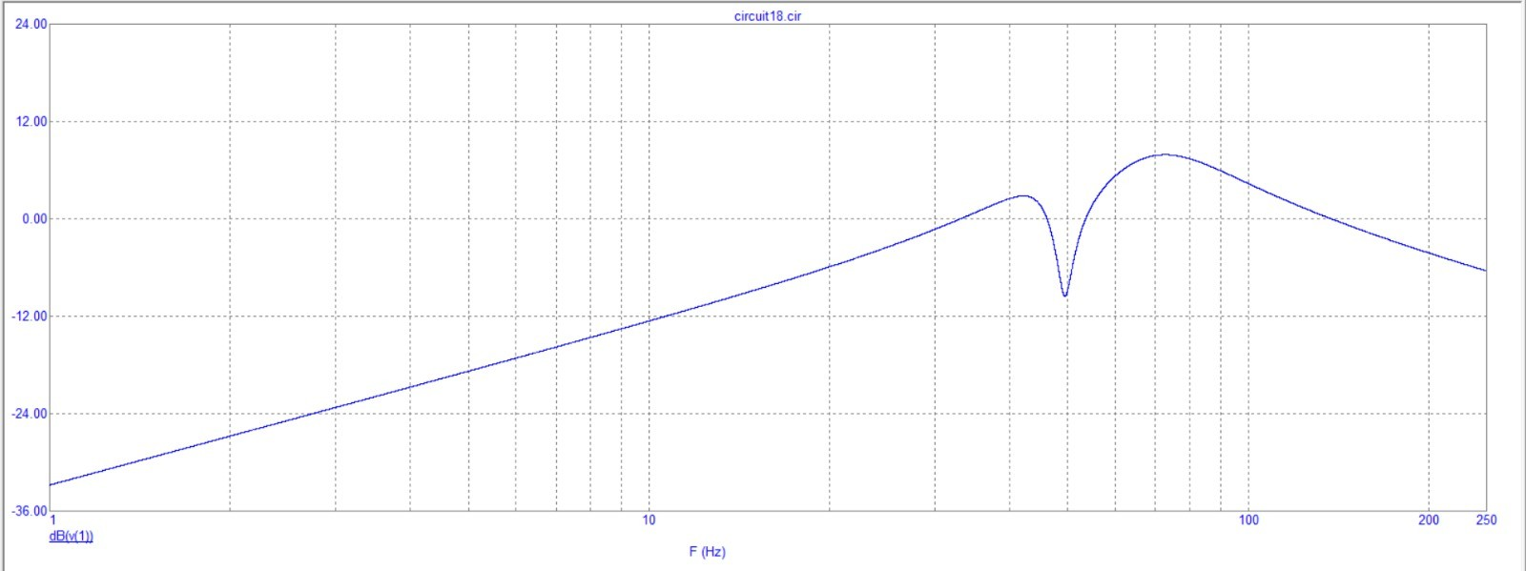

LabWork
SIMULATEDCIRCUITRESPONSE

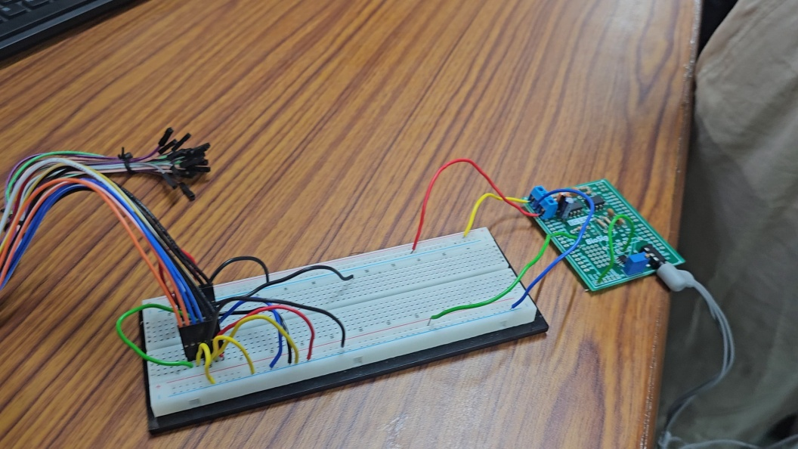

IMAGE SHOWINGTHE FINALPCBAND CIRCUITASSEMBLY

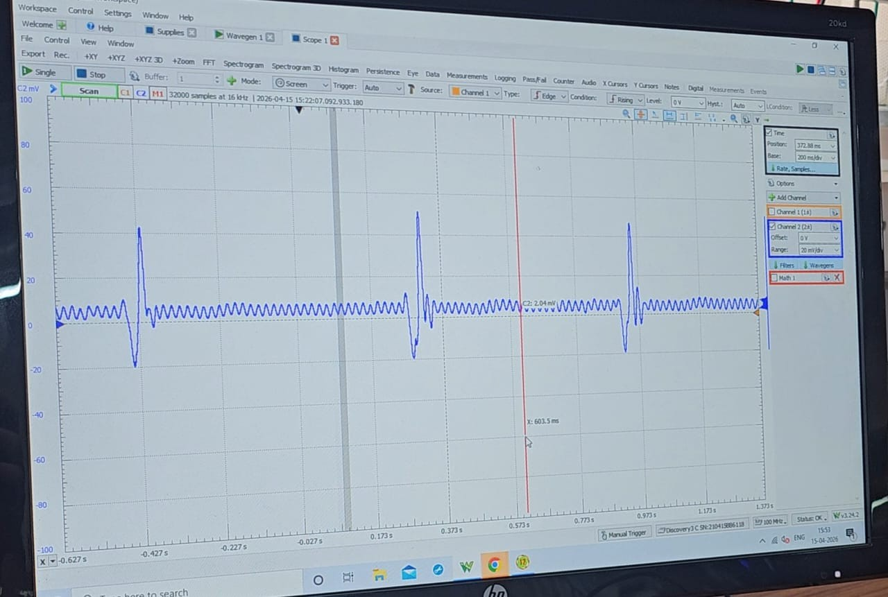
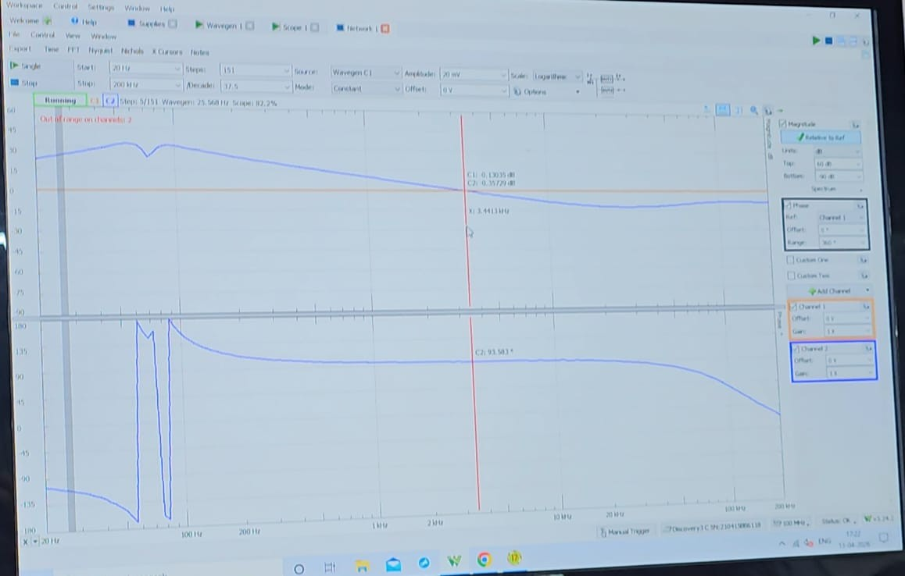
IMAGESHOWINGTHEREALTIMEMEASUREMENTOFECGSIGNAL.

FREQUENCYRESPONSEOFTHEFINALCIRCUIT,WITHNOTCHAT50 HZ

